

Every writer or author, if they are serious about their craft, must have a website that highlights and showcase who they are and what they do. Having a website is vital because it is a promotional tool, regardless if you have one book or twenty; and regardless if you are a newbie or a novice writer. The website will show off your passion, your book or books and give an introduction into the spirit of who you are as a writer. The website is your author bio, the billboard that helps you get notice, especially when you are dealing with cyberspace. After all, you can reach for more people, readers and book-buyers when you are advertising on the internet. Once your site goes live, the word gets out.
So, what kind of information goes into an author’s website? Read my blog page to find out @ www.born2write.weebly.com
Be in the know!

FYI: For February, “Broken Voices” made it to the best seller list on Amazon.com. This is a book that deals with disabilities. A must read for all.

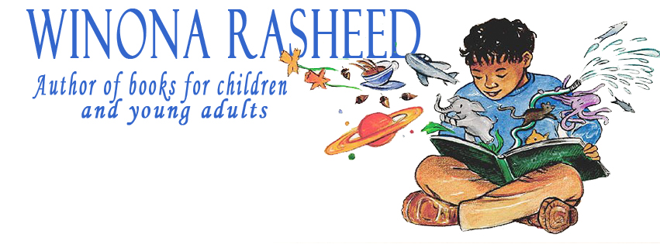

Do You Need A Website, Really?

Do You Need A Website Really?

In the Know!

Shades of Inspiration Newsletter

March 1, 2013
Volume 2, Issue 2

Shades of Inspiration

The Author and Networking

Promoting, promoting, promoting; that’s the name of the game once you have a book published.
I love promoting my stuff, ask anybody who follow me on Facebook, Twitter and my blog chats. I’m always posting something somewhere. I try to keep my messages entertaining, informative and inspirational. Most of the time, I’m doing nothing more than promoting my books, my events, activities or just hanging out as I go about socializing over the internet with family, friends and newcomers. As an author, I love the social media outlets because they let you express yourself and interact with so many people. I enjoy receiving responses and comments, which mean… people, are reading your messages. What better way is there to communicate with people near and far?
Social media is an excellent marketing and promoting tool for authors as you walk through cyberspace spreading the word and connecting with those who follow you; all the while, picking up new people, leads and resources as you walk through the pages or outlets of the internet.
My advice, take advantage of all the doors that open, which will let you strut your stuff as an author; putting yourself and the books you create in the spotlight, a cyber-light that shines worldwide. Imagine the exposure, because that’s what it is all about when you “connect” as an author, you will want and need the exposure as you let your little light shine.
Struttin’ My Stuff!



Shades of Inspiration page 2

Purchase these children books from Amazon.com

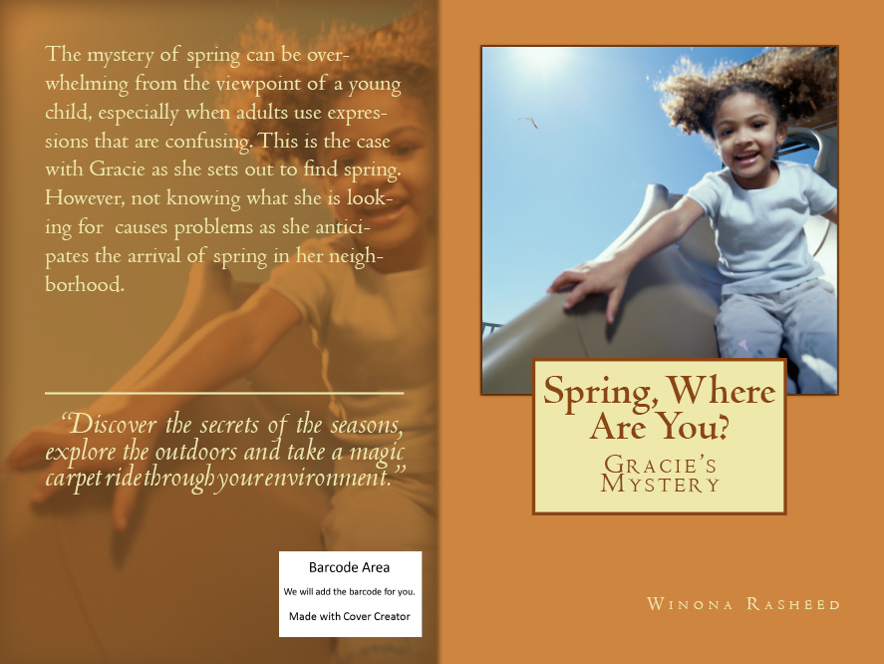

Relationships come and go, but when you find a true friend and mentor, you better hold on to them. This is Catherine Burr, a fabulous lady who inspires, encourages and who enjoys sharing her knowledge and experiences with others. She will go over and beyond in assisting and informing writers who want to be in the know. I have learned a lot from her in my career as a writer/author. She is my shining star. When it comes to writing, you will find her blogs and website to be very informative and inspiring, making you want to take out a pen and write. You can trust her advice and her insight. As a writer, she has published books that will entertain both the young and the old.

For March, Shades of Inspiration salutes and recognizes this unique and remarkable writer/author and publisher.

Visit her website @ www.catherineburr.com

You will like what you see! I guarantee you will be impressed! Be in the know with Catherine Burr.

Winona Rasheed is a freelance writer and an author of children books. She loves writing, being creative and inventive. You can see her imagination at work in the 7 books that are published. She writes articles on a weekly basis and she tries to blog daily, and now she is launching a newsletter. She aims to inform. You can find her on Twitter, Facebook, Google + every day, for when she isn’t working, she is hanging out with her friends in cyberspace.
http://born2write.weebly.com/
Stop by and visit her on Weebly, and while you are there…read and follow her blog.
.
.
The Author and Social Media
Promoting, promoting, promoting; that’s the name of the game once you have a book published.
I love promoting my stuff, ask anybody on Face-book, Twitter and my blog chats who follow me in one way or the other. I’m always posting something, somewhere. I try to keep my messages entertaining, informative and inspirational. Most of the time, I’m doing nothing more than promoting my books, my events, activities and hanging out as I go about socializing over the internet with family, friends and newcomerAs an author, I love the social interact with so many people. I enjoy getting responses or comments, which mean people are reading your messages. What better way is there to communicate with the masses of people near and far at one time?
This social media is an excellent marketing and promoting tool for authors as you walk through cyberspace, spreading the word and connecting with those who follow you; all the time picking up new people, leads and sources as you walk through the pages or outlets of the internet.
My advice, take advantage of all the doors that open, which will let you strut your stuff as an author; putting yourself and the books you create in the spo

Author Spotlight
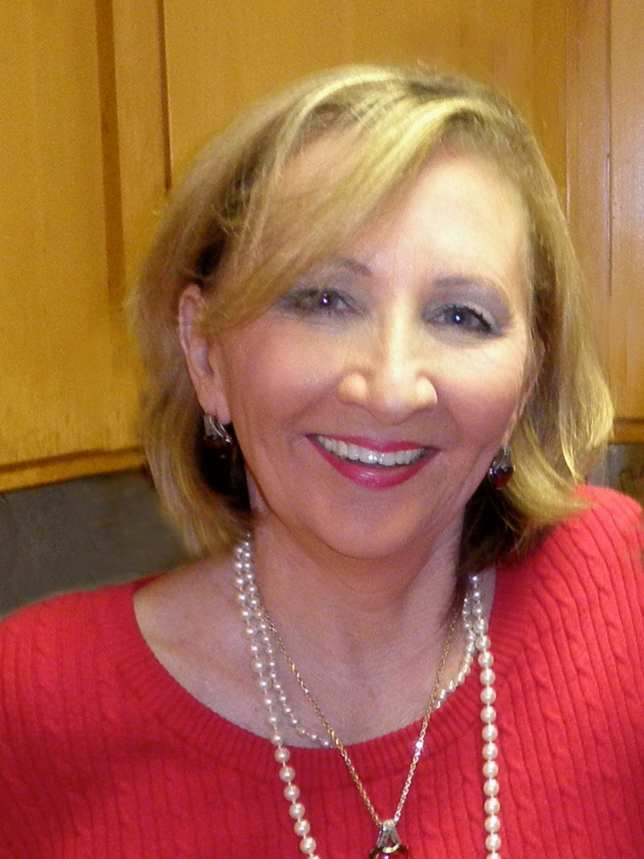

My Latest Books

